Final Project Documentation and Wireframes

Styling Rules
The first time a styling rule shows up I will explain it in detail. When it shows up again I will only briefly touch on it.
* {  box-sizing: border-box;  padding: 0;  margin: 0;  font-family: 'Times New Roman', Times, serif;  } | The default styling rule for everything. By default, every element will have a padding and margin of 0. The text will be in the font family “Times New Romans”. The box-sizing: border-box component indicates how the elements will be shaped, with the height and width only applying to them.
.container{  display: grid;  grid-template-rows: repeat(18, 1fr);  grid-template-columns: repeat(4, 1fr);  grid-gap: 2px;  height: 100vh;  } | The container class is used to make the elements displayed in a grid style, making it easier to choose specifically where each element is placed. Grid-template-rows indicates that there are 18 cells on the web page where an element can be placed, and the 1fr means that each row takes up 1 fraction of the available space. Grid-gap: 2px indicates a 2px gap between each grid element. Height: 100vh indicates that it takes up 100 percent of the viewport.
header{  grid-column: 1/5;  grid-row: 1/3;  background-color: lightgreen;  border-radius: 10px;  border: 2px solid black;  } | This CSS element dictates the rules for a header tag. Grid-column: 1/5 indicates that this element will take up the grid horizontally from column 1 up to, but not occupying, column 5. Grid-row: 1/3 is similar, in that the header will take up space vertically from row 1 up until row 3. Border-radius: 10px rounds the corners of the element by 10px to give it smoother corners. Border: 2px solid black gives the header a solid black border that is 2px in length. It has a background color of “lightgreen”.
nav{  grid-column: 1/5;  grid-row: 3/4;  background-color: lightgreen;  border-radius: 10px;  border: 2px solid black;  } | This CSS element describes the navigation bar. It positions it, gives it a background color, border-radius, and border.
footer{  grid-column: 1/5;  grid-row: 18/19;  background-color: lightgreen;  border-radius: 10px;  border: 2px solid black;  padding: 10px;  } | This CSS element describes the footer. It gives it a position, background-color, border-radius, border, and padding.
h1{  text-align: center;  } | This CSS element aligns the text of the h1 element to the center of it’s container.
h2{  padding: 10px;  } | This sets the padding of the h2 elements.
h3{  padding: 10px;  } | This sets the padding of the h3 elements.
p{  padding: 10px;  } | This sets the padding of the p elements.
article{  background-color: #70FA9D;  border-radius: 10px;  border: 2px solid black;  } | This sets the background-color, border-radius, and border of the article elements. Notice how I use hexadecimal to set the background-color. This is done using the Adobe Color Wheel, and is a useful alternative when you want a specific color that CSS does not have a key word for.
aside{  background-color: #67FACC;  border-radius: 10px;  border: 2px solid black;  } | This sets the css for the article elements. It sets the background-color, border-radius, and border for it.
header img{  position: relative;  top: -50px;  left: 880px;  } | This CSS is used to define any images that are inside of a header tag. The position of it is set to relative. This means that it is placed relative to the container that it is in. It is not taken out of document flow. It is placed -50px from the top of where it would originally be, and from the left it is placed 880 pixels from where it would originally be.
a{  text-decoration: none;  padding: 10px;  border: 2px;  margin: 2px;  } | This CSS defines anchor tags. It sets the padding, margin, and border of it. Text-decoration: none; indicates that it will not have any extra elements added to the text. In this case the text will no longer be underlined.
.preview{  grid-column: 3/5;  grid-row: 4/18;  } | This class defines where “preview” it will be on the grid.
.about{  grid-column: 1/3;  grid-row: 4/18;  } | This class defines where “about” it will be on the grid.
@media screen and (max-width: 800px){  .container{  grid-template-rows: repeat(36, 1fr);  grid-template-columns: repeat(4, 1fr);  height: 200vh;  }  .preview{  grid-column: 1/5;  grid-row: 18/34;  }  .about{  grid-column: 1/5;  grid-row: 4/18;  }  footer{  grid-row: 34/36;  }  } | @Media screen is used to make the page respond to changing its size. In this case, new CSS rules will override the old ones if the page width reaches 800px or less. The same styling rules are included here, the only difference being that they have different values so that the screen looks more natural if the screen size shrinks.
.welcome{  grid-column: 1/3;  grid-row: 4/9;  } | This class defines “welcome” where it will be on the grid.
.news{  grid-column: 1/3;  grid-row: 9/18  } | This class defines where “news” will be on the grid.
.welcome img{  position: absolute;  left: 200px;  top: -30px;  } | This class defines the positioning of any images that are within an element that has the class “welcome”. Notice how the position is set to “absolute”. This is different from relative positioning in that absolute positioning takes an element outside of normal document flow. This means that the element will not be placed relative to the container it is in, and instead will be placed in the top left corner of the screen. The left and top styling rules move it from this spot.
.stay-tuned{  position: relative;  top: -140px;  text-align: center;  } | This class sets the position to relative and moves it from the top. The text is aligned to the center of the element.
@media screen and (max-width: 800px){  .welcome{  grid-column: 1/5;  grid-row: 4/10  }  .news{  grid-column: 1/5;  grid-row: 10/18;  }  } | Same as before, this CSS changes the positioning of certain classes on the grid if the screen size is at 800 pixels or less.
.story{  position: relative;  width: 400px;  } | This sets the width and position type of class “story”.
.slug5{  scale: 0.3;  position: absolute;  border-radius: 20px;  top: 90px;  left: 200px;  } | This class sets the scale of the element to 0.3 of its original size. It also sets it to absolute positioning, gives it a border-radius, and moves it from the top and left of its original position.
.slug6{  scale: 0.3;  position: absolute;  border-radius: 20px;  top: 290px;  left: 200px;  } | This CSS class sets the scale, position type, border-radius, and position of the class “slug6”.
.knight{  position: absolute;  scale: 0.4;  top: 35px;  left: 1100px;  } | This CSS class sets the position type, scale, and position of the class “knight”.
.boombuh{  position: absolute;  scale: 0.5;  top: 375px;  left: 1100px;  } | This CSS class sets the position type, scale, and position of the class “boombuh”.
@media screen and (max-width: 800px){  .knight{  top: 600px;  left: 300px;  }  .boombuh{  left: 300px;  top: 900px;  } | This media query changes the positions of classes “knight” and “boombuh” if the width of the screen is at 800 pixels or less.

Wireframe Diagrams

Home Page Desktop:
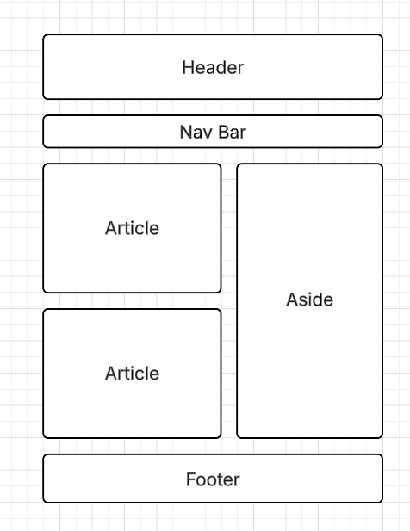

Home Page Mobile:
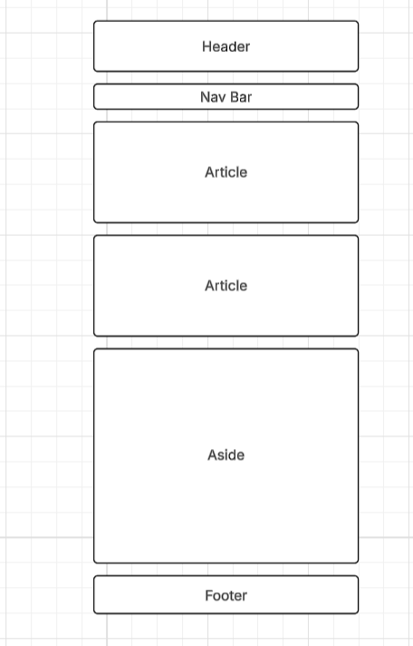

About and Game Page Desktop:
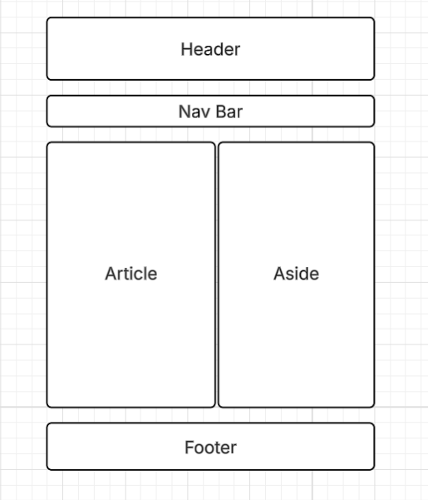

About and Game Page Mobile:
